Peppermint

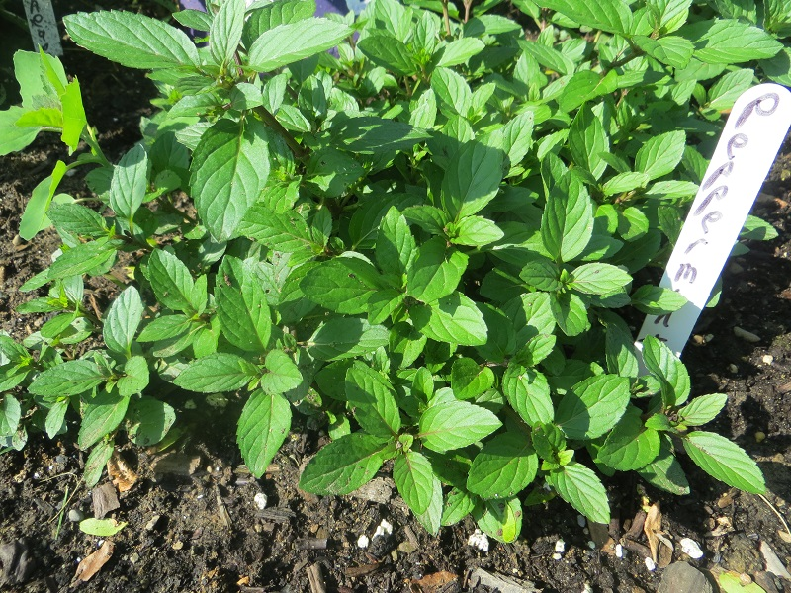
Peppermint

While mint plants flourish all over the world, they are native to the Mediterranean and were spread by the Roman Empire. A Greek myth tells of an elderly couple taking the time to wipe down their table with mint leaves before serving a meal to traveling strangers. When the strangers revealed themselves as the Gods Zeus and Hermes, the couple was rewarded and the herb was then associated with hospitality! There is nothing nicer too, then visiting with friends over a nice cup of Peppermint tea.

People have used Peppermint for thousands of years. The ancient Egyptians, Romans and Greeks added it to meat dishes and wine and utilized the leaves as a decoration for special occasions. Peppermint oil has antibacterial and antiseptic qualities. Herbalists prescribe Peppermint tea as a remedy for chest congestion, stomach troubles and headaches….and recommend Peppermint skin lotion as a pain reliever. Peppermint oil also enhances the fragrance of potpourri, cosmetics, shampoos, soaps and perfumes. Its leaves and oil add flavor to salads, desserts, teas, and sauces, as well as breath mints, chewing gum, toothpaste and mouthwash.

Growing Mint

For the best leaf production, mint should be planted in full to partial sunlight. It will grow in most types of soil, but thrives best when it’s not constantly wet. The plants can be counted to reproduce on their own, but additional plants can be grown by stem and root cuttings. The mint plant is notorious for running rampant in gardens! Many gardeners choose to grow them in containers to prevent gardens from becoming nothing but dedicated mint beds! (So far, I’m controlling my mint ok….we’ll see what happens ) However, with containers, you have to be careful the pot is big enough so you don’t get root bound and the plant dies. That happened to me last year and I was so bummed! The spread can be kept to a manageable level by steadily harvesting the leaves of the plant. Peppermint plants grow to about 2 feet tall if allowed. Tiny oil glands in the leaves release volatile oils, giving the plants their wonderful fragrance.

Hybrids

There is an amazing number of mint hybrids out there now. Peppermint and Spearmint are the two most traditional forms. Smooth-leaved peppermint has the most potent amount of menthol, while spearmint, with toothed and often curly leaves, has a sweeter flavor. Varieties with a hint of fruit flavor abound! Including apple, orange, pineapple, lemon, lime and even banana! And yes, there is Chocolate mint….it’s growing in my garden and it’s wonderful!

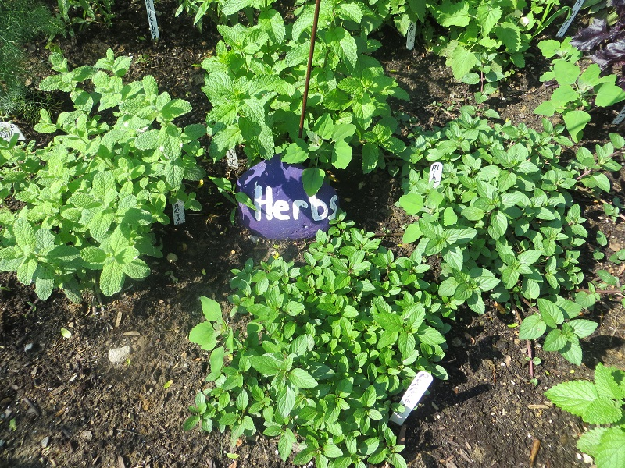
In the front is Peppermint..moving clockwise is Pineapple Mint,
Then Spearmint, and then really wonderful Chocolate mint.

Drying Mint Leaves

The simplest way is to cut the stems down low on the plant….wrap a bunch of them together and hang them upside down to dry in a warm, dry place. I hang mine from hooks in my ceiling. I’ve also used a peg board and a clothes drying rack. If the leaves are removed from the stem, just spread out on a clean metal screen, a tray, a basket and let them dry. You can also dry them in a low temp oven.

Culinary Uses

Mint leaves can be added to mixed greens in a salad, can be candied or jellied, and can be made into a simple syrup. Mint is often used in sauces for lamb dishes and are a popular way to flavor peas. They can flavor homemade ice cream and granitas. One of my favorite ways to have mint is crushed into mint juleps or mojitos! They can also be made into wonderful herbed ice cubes that make tea, lemonade and just water so refreshing!

Medicinal Uses

Peppermint, in tea form, aids upset stomachs, flu and can be used to ease hiccups. Inhalation of the leaves in boiling water is recommended for head colds and asthma. Mint tea can be used instead of aspirin for headaches, especially menstrual –related headaches. Some headaches can be relieved if you lie down in a dark room with fresh peppermint leaves on the forehead or a bit of peppermint essential oil on your temples. (be careful your skin is ok with that first) Mint aids in respiratory and circulatory systems, it’s also an anti-inflammatory and an antiseptic. It’s ideal for treating indigestion, flatulence, varicose veins, skin irritations, rheumatism, toothache and general fatigue. I, for one, find Peppermint spray brings me out of the “lazies”. Peppermint oil can help to relieve earaches when a few drops are placed in the ear. The oil or a mesh bag of the leaves in your bath is wonderful when you have a cold or need to soothe your skin, or to re-energize yourself!
Peppermint tea with honey soothes a sore throat. A few drops of the essential oil mixed with water and applied to a cloth, will help burning and itching skin, sunburn and relieve when you get overheated. As a lover of all things herbal, I love to add some peppermint, lemon and lavender essential oils to witch hazel…it makes a wonderful body/face spray to cool you too. Peppermint is a necessity in every Witch’s cupboard and garden bed! It’s in my top five!!

Magickal Properties

Gender: Masculine
Planet: Mercury or Venus
Element: Air
Deity: Zeus and Hermes
Magickal attributes: Money, healing, strength, augments power, luck, travel, cleansing, consecration, dreams, happiness, love, passion, prosperity, protection, psychic development, purification, release, renewal, rest, sleep, animals, divination, endings, energy, exorcism, grieving, spirit offerings, success and transformation.

To use Peppermint in Magick….these are just some of the ways:

-Mint is a premier healing herb and can be used in healing charms, baths and incenses
-For a bath, place leaves in a mesh bag and hang under the running tap, or add a few drops of the oil to the water before you get in.
-Use to increase the vibrations of a space or in spells and incense for purification and healing
-Place in a sleep pillow to ensure peaceful sleep and bring about prophetic dreams
-Use to anoint your altar, body and candles
-Burn in your home to clear illness and negative energy
-Use in magickal workings to provide to gear up the energy level
-Carry in a mojo bag to boost healing, love and abundance
-Make a tea and sprinkle the water around your home to bring peace, happiness and protection
-Drink it for its ability to enhance your power before doing a ritual, spell or meditation
-Carry a few leaves in your wallet to bring money and prosperity and success
-Use the oil in a burner, in room or body sprays or as a simmering pot on the stove to lift the spirit and energy in your home
-Grow it…for protection, prosperity, health, luck and abundance!

